Step-by-Step Instructions – CITI Biosafety Training
How To Register:
- From the homepage (CITI), click the REGISTER on the upper right portion of the screen.

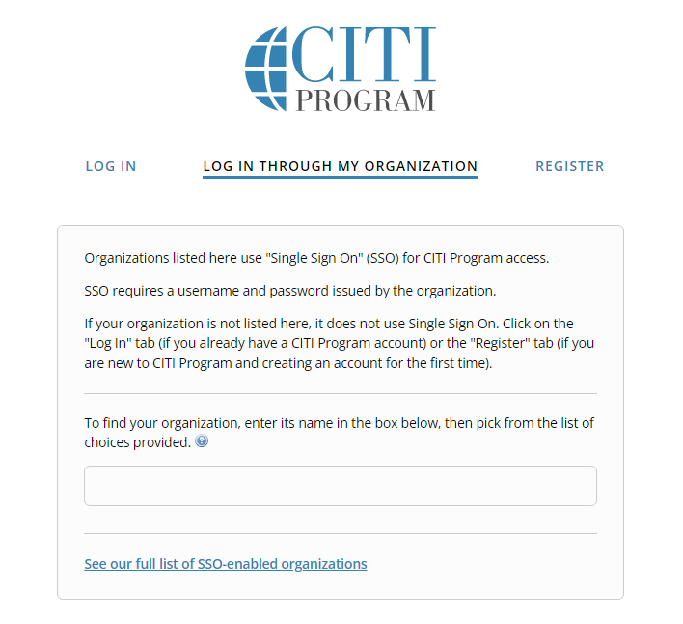

- Choose a participating organization from the search box. Please select “Central Michigan University”.
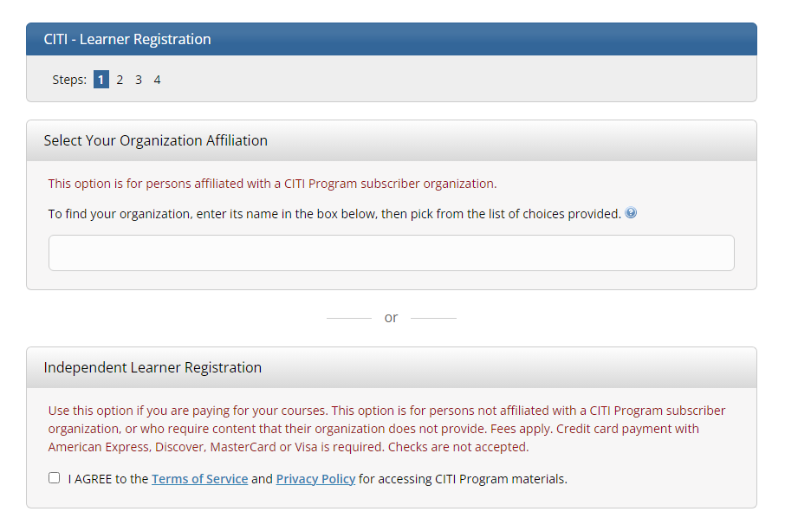

- Read and agree to the Terms of Service and check “I affirm that I am an affiliate of Central Michigan University”.
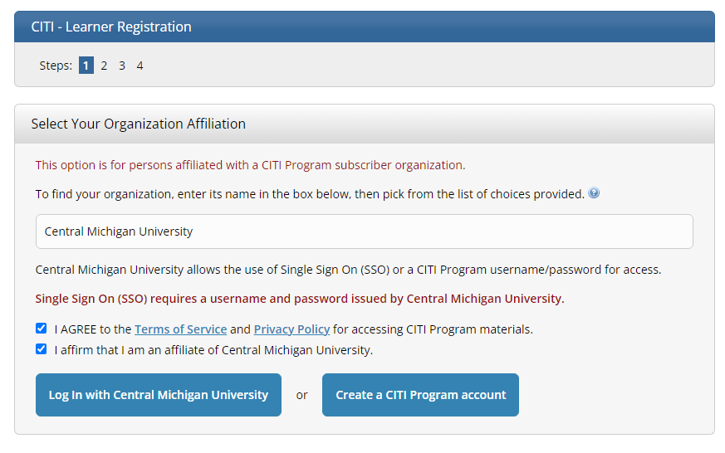

- Click “Create a CITI Program account”, and input you first name, last name, and CMU email address,
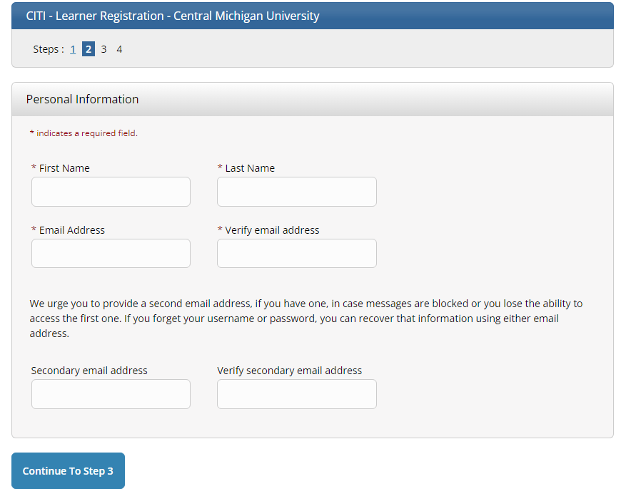

- Click “continue To Step 3”, choose a username and password for your account, and follow the on screen instructions. NOTE: passwords are case sensitive.

You will also select and answer a security question. This question will be used to assist in the recovery of your account if you have forgotten your username or password.
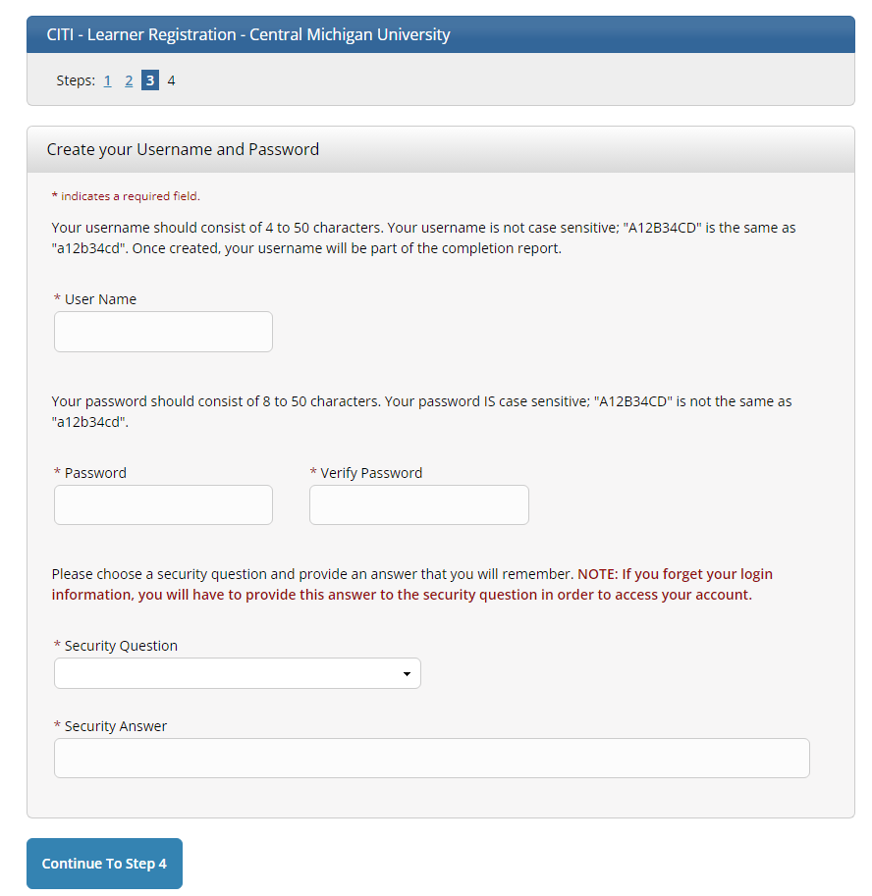

- Complete the remaining steps to complete new user registration.

How to Select Biosafety Training:
- On your Main Menu, select “Add a Course” under “Learner Tools for Central Michigan University”.
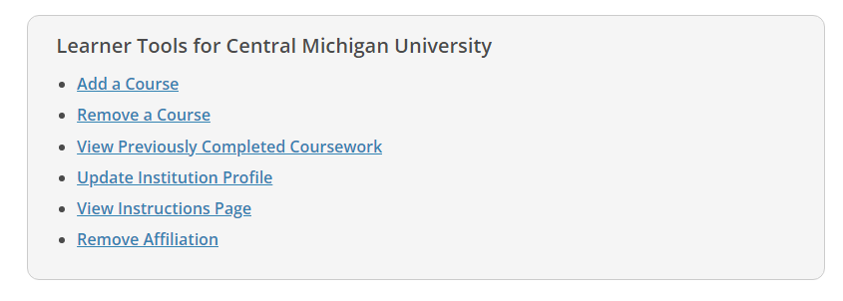
- Select Biosafety/Biosecurity and click Next.
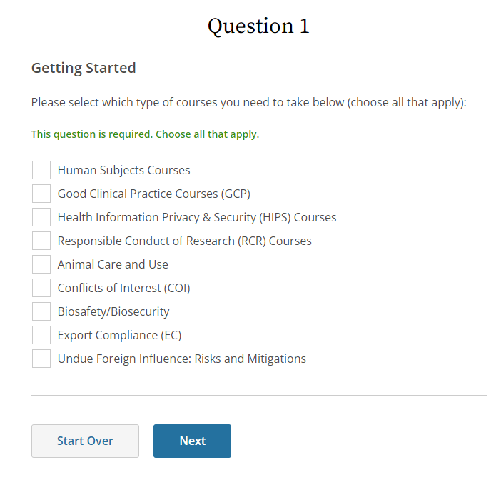

- Select appropriate Biosafety/Biosecurity training.
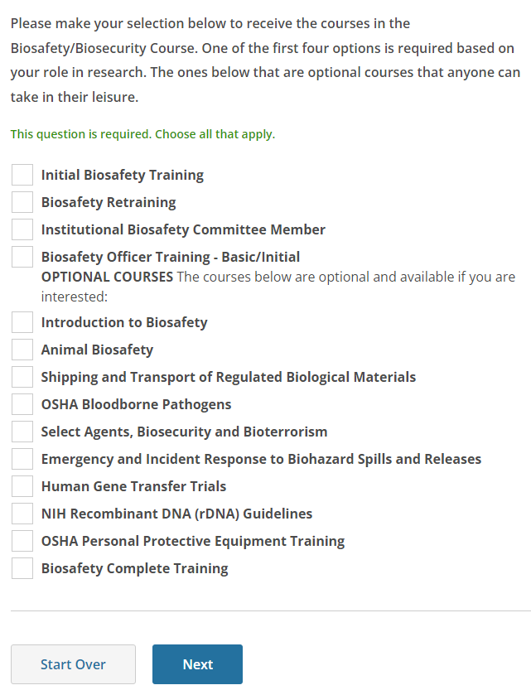

- Complete the remaining steps to complete biosafety training selection.

